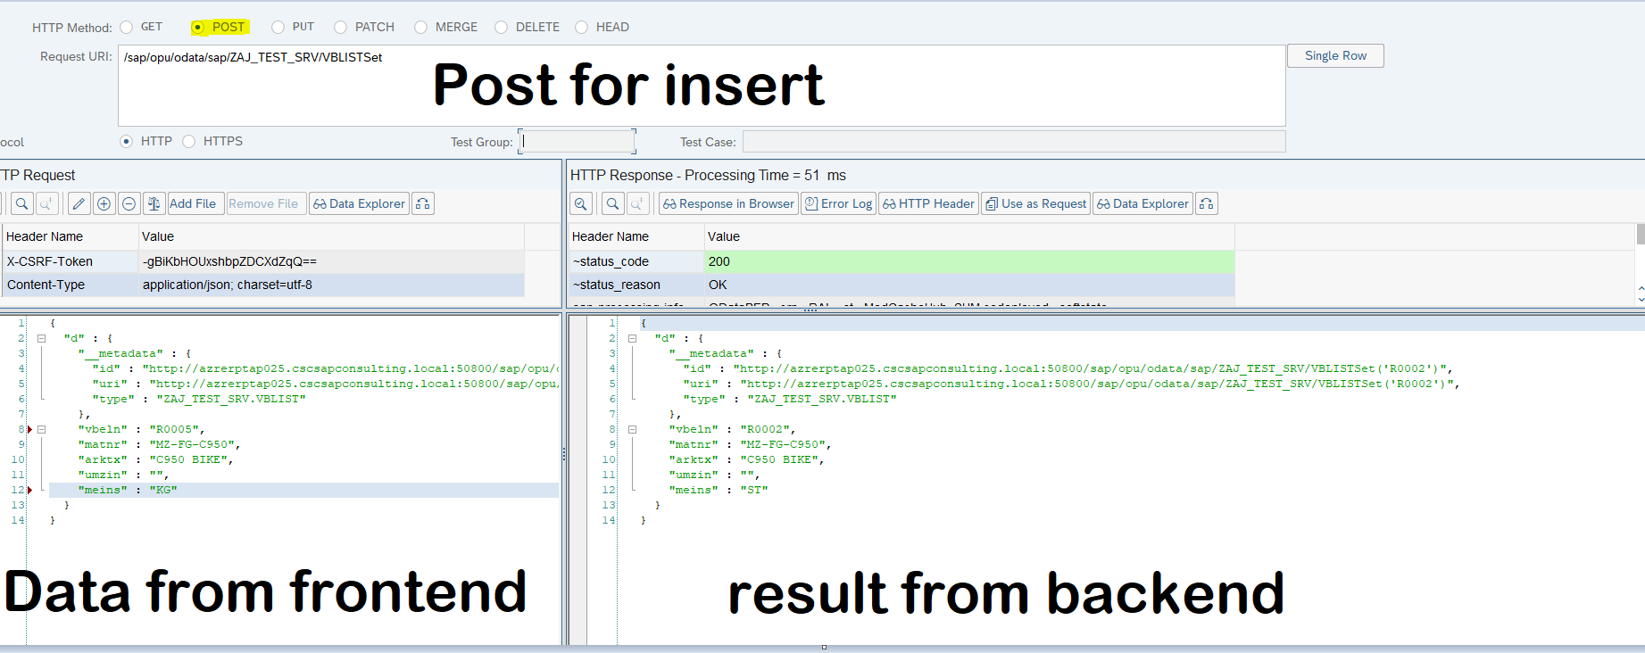

Gv_input_data has the data of user input.  
move it to the structure of vbap then insert

Move it to er_entity to show the result in http response

Note: add validation like if the id exist create another(can use MAX to get the latest id existed and add 1 if user input is same. ex. 000801 in DB latest data, user input is 000801 if same +1 to become 000802).

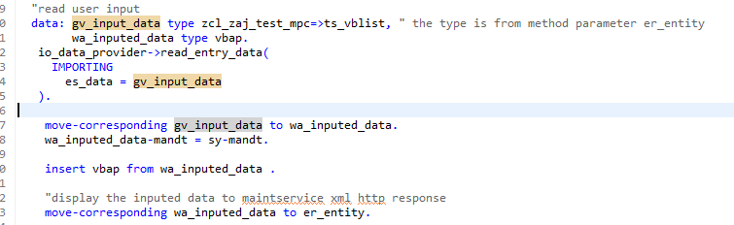

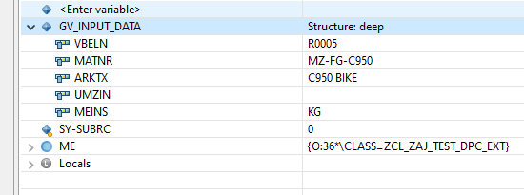

Data displayed after moving the data to er_entity

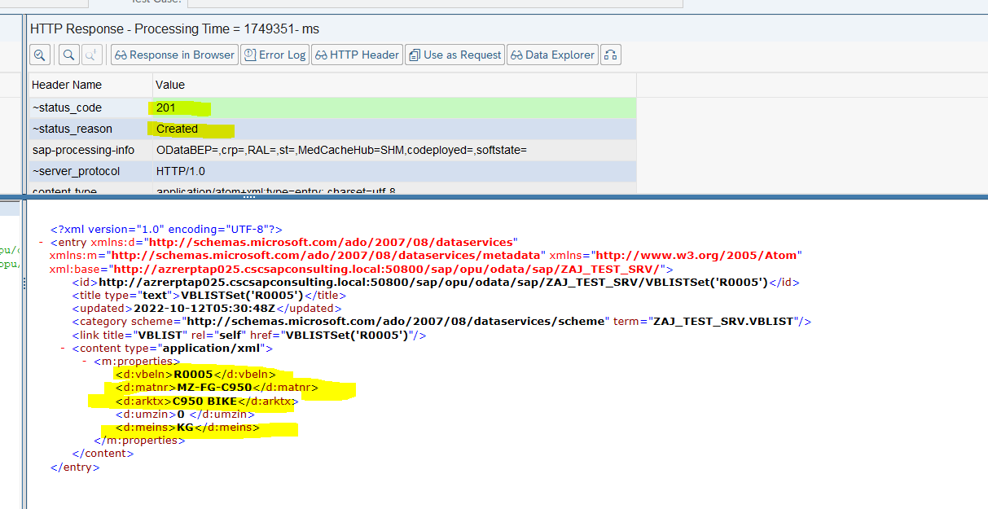

Insert Success  
